Effect of Rigid Arc Attached at Ends to McKibben Mesh

Purpose
Investigate the boundary between the free McKibben muscle (MKM) and constrained MKM regions. Identify system constraining factors.

Materials
- 5x 200mm Long PEEK Mesh, ¼” relaxed 1/2” expanded https://www.mcmaster.com/2656k11/
- 5x White long balloons
- Small zip ties

Procedure
Printed plastic structures centered on the length of the MKM mesh & attached at either end:
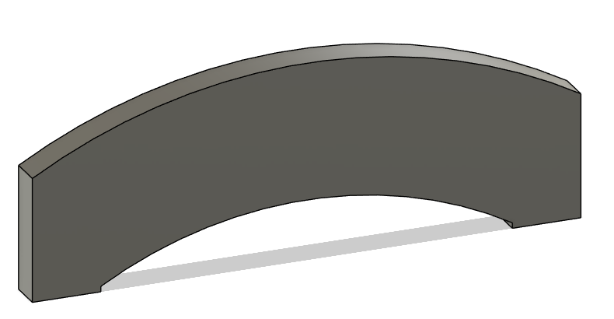
Muscle # | Overall Length (mm) | Plastic Length (mm) | Arc Height off Mesh (mm) | Arc Thickness (mm) | Plastic Width (mm) | Attachment Region Length (mm)
1 | 200 | 40 | 4 | 10 | 2.5 | 5
2 | 200 | 65 | 4 | 10 | 2.5 | 5
3 | 200 | 80 | 4 | 10 | 2.5 | 5
4 | 200 | 95 | 4 | 10 | 2.5 | 5
5 | 200 | 110 | 4 | 10 | 2.5 | 5

Inserted balloon through mesh, tied distal end of balloon, and zip-tied distal end of balloon and mesh together tightly.
Attached proximal end of balloon to air gun with a zip tie and inflated balloon. Observed MKM deformation.

Deviations
65 mm arc had to be printed twice due to poor attachment to the mesh on the first print. The first print came off the mesh, but pulled a strand with it, so that mesh is missing a strand. Decided to print a second time with first layer temp increased from 240C to 250C, which seems to have worked.
80 mm arc failed to stick to mesh on the first print, decided to print it a second time with the first layer repeated 3 times and printed at 260C.

Results

